Ethical Hacking & Vulnerability Assessment Report (Week 5)

Objective
To perform ethical hacking on a test web application using penetration testing techniques, identify vulnerabilities such as SQL Injection, CSRF, and sensitive data exposure, and implement appropriate security controls.

1. Reconnaissance Phase

Tools Used
- Kali Linux
- Nmap
- curl

Findings
- Port 8443 (HTTPS) identified as filtered via scan
- Indicates presence of security controls (filtering)
However:
- Manual verification using curl confirmed:
  - ✔ Service is accessible
  - ✔ Only automated scanning is restricted

Screenshot 1: Nmap Scan Result
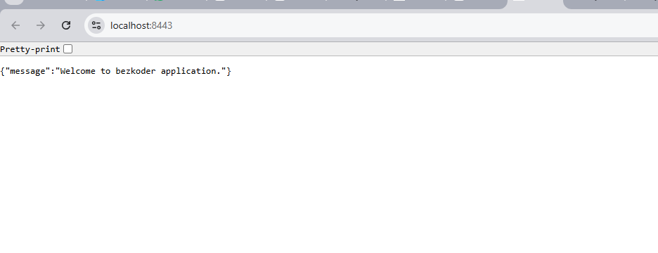

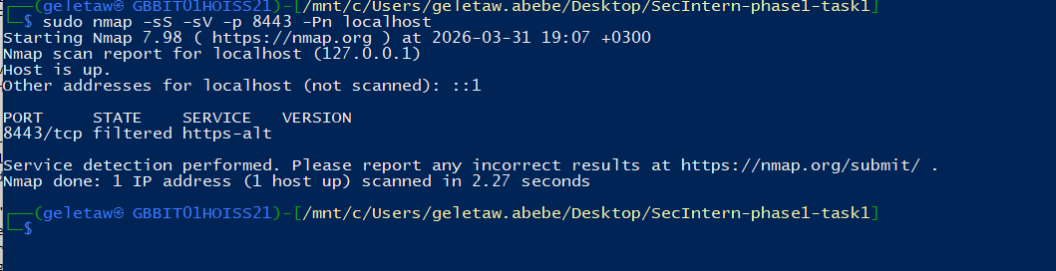
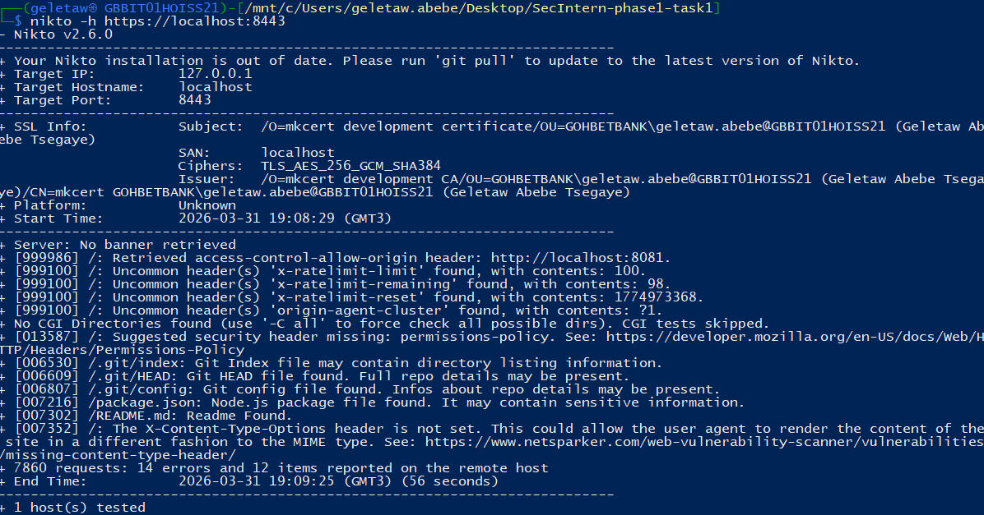Description:
Shows port 8443 as filtered.

Screenshot 2: curl HTTPS Verification
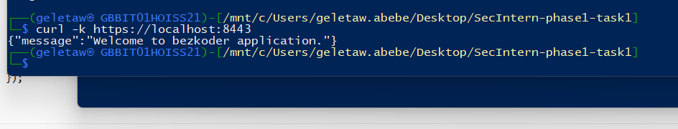Description:
Manual request confirming service availability.

2. Directory Enumeration (Gobuster)

Tool Used
- Gobuster

Findings
- Automated enumeration attempts:
  - ❌ Blocked (connection refused)
  - ❌ Rate limiting observed
Indicates:
- Anti-scanning protection
- Request filtering

Manual Enumeration Result

CRITICAL Vulnerability
.git/HEAD
.git/config
.git/index
Exposed Git repository

HIGH RISK
package.json
package-lock.json
Reveals:
- Dependencies
- Versions
- Potential vulnerable libraries

MEDIUM
/app → redirect (301)
/node → unknown endpoint

NORMAL
favicon.ico

Screenshot 3: Gobuster Output

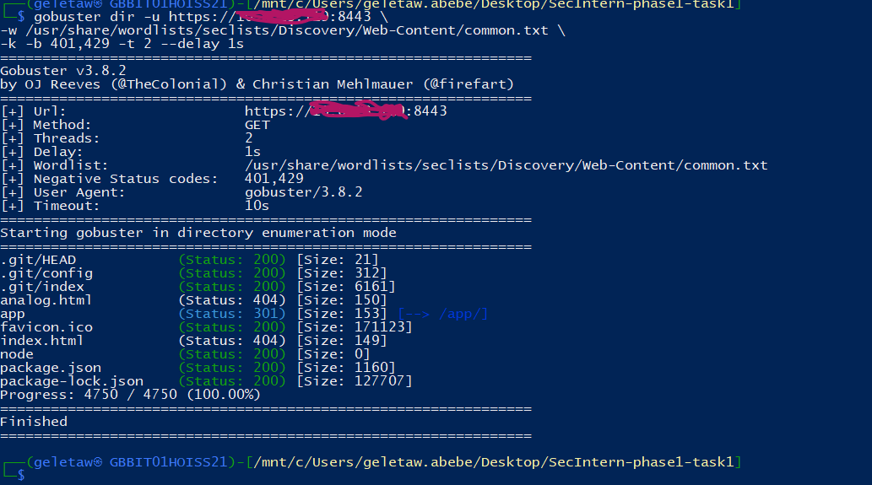
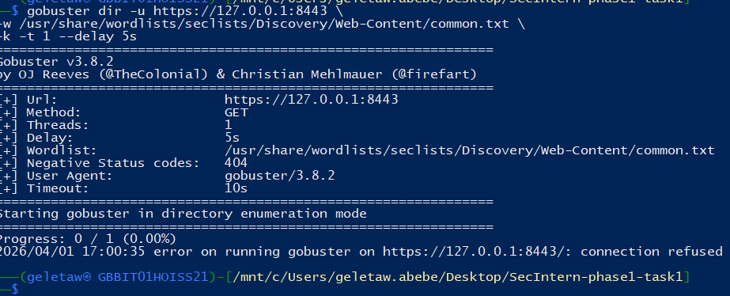

Screenshot 4: Accessing .git Files

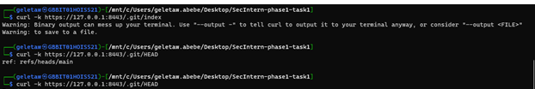

3. Critical Vulnerability — .git Exposure

Impact
Exposed .git directory allows attackers to:
- Download full source code
- Access commit history
- Identify sensitive data (API keys, secrets)
- Analyze backend logic
This is a REAL-WORLD CRITICAL vulnerability

Fix Implemented
- Removed .git from production
- Blocked hidden files via server config

Screenshot 5: .git Access Before Fix



Screenshot 6: .git Blocked After Fix
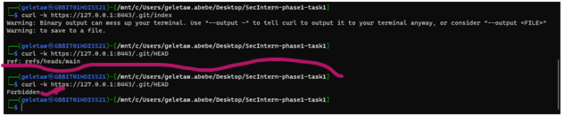

4. SQL Injection Testing

Tools Used
- Manual payload testing
- SQLMap

Findings

Manual Testing:
' OR 1=1 --
Result:
- ❌ No injection successful
- ✔ Input validation present

SQLMap Results
[CRITICAL] all tested parameters do not appear to be injectable

Additional Observations
- Rate Limiting:
429 Too Many Requests
- Many 404 responses:
404 Not Found

Screenshot 7: SQLMap Output
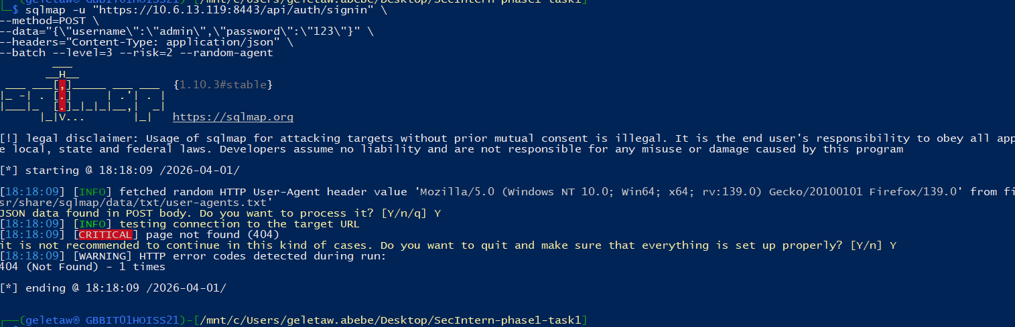

Important Note
No SQL Injection ≠ Secure Application
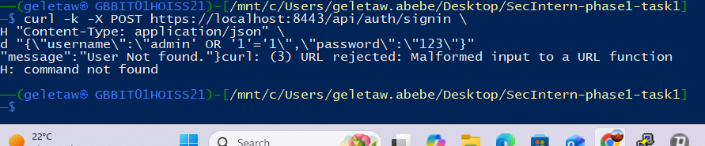

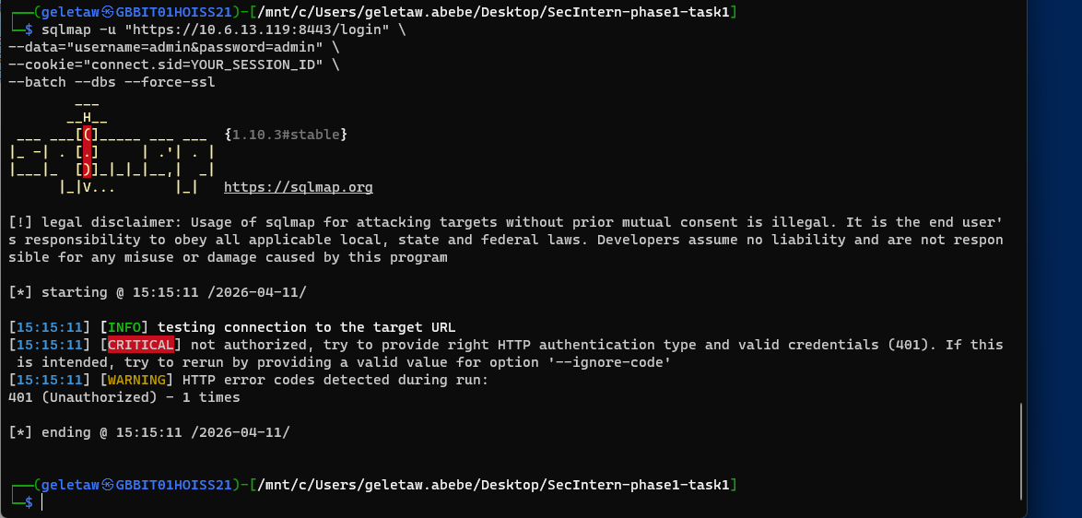

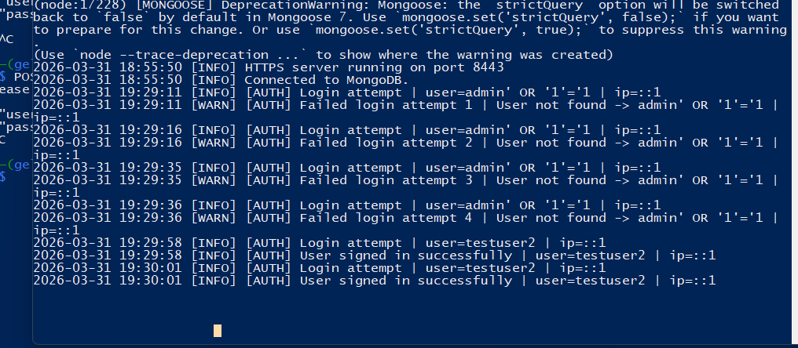

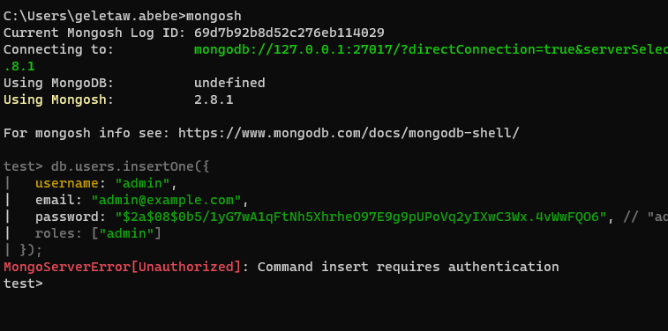

DB access Based on Role:
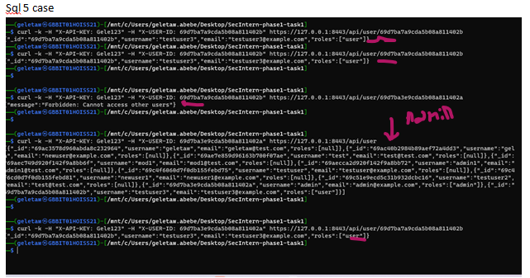

5. CSRF Testing

Tools Used
- Burp Suite
- Browser
- Custom CSRF test form

Findings

Before Protection
- ✔ Request replay possible
- ✔ Action executed without validation
Application was CSRF vulnerable

Screenshot 8: Burp Request Intercept
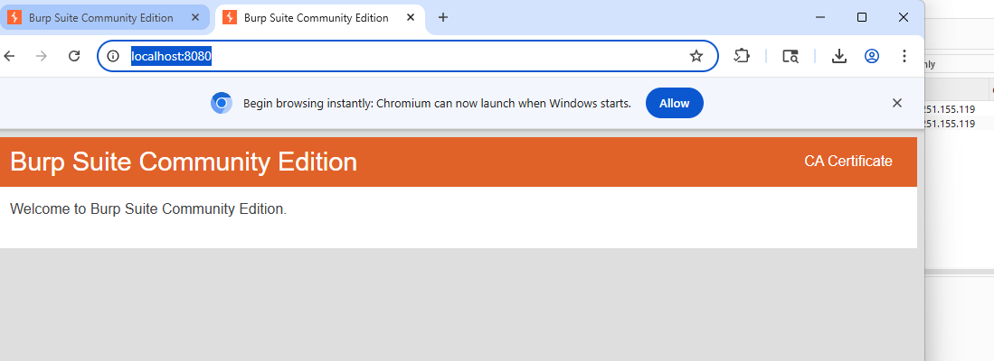

📸 Screenshot 9: CSRF Replay Attack
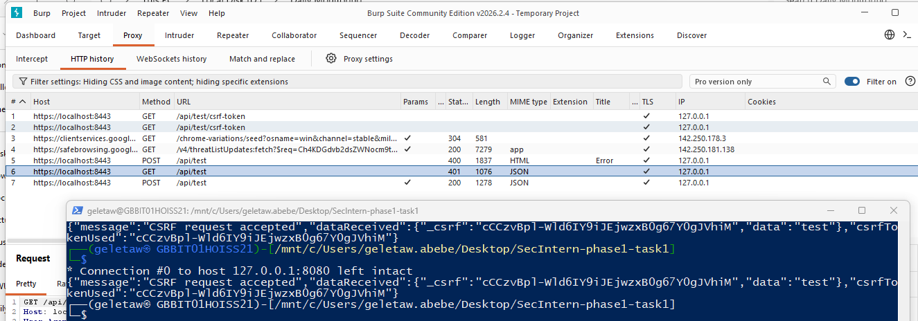

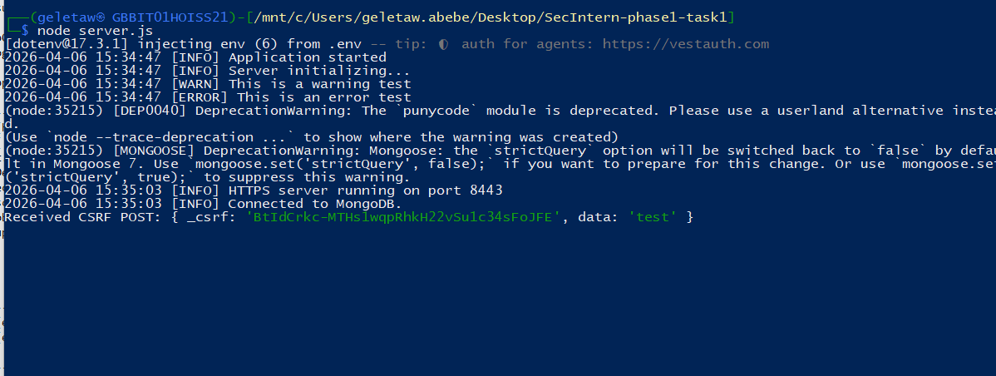

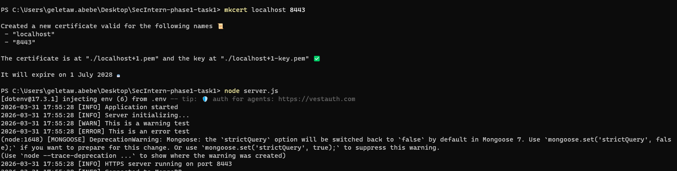

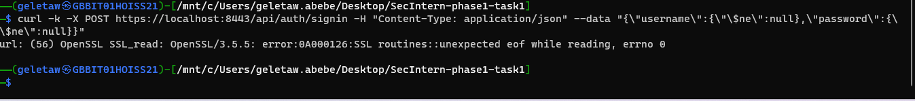

6. CSRF Protection Implementation

Tool Used
- csurf middleware

Implementation
const csrf = require('csurf');
const cookieParser = require('cookie-parser');
app.use(cookieParser());
app.use(csrf({ cookie: true }));

Result
- ✔ Requests without token → blocked
- ✔ Valid token required
BUT:
“With key replayed still vulnerable”
This indicates:
- Token reuse issue OR
- Token not invalidated properly

Screenshot 10: CSRF Token Added
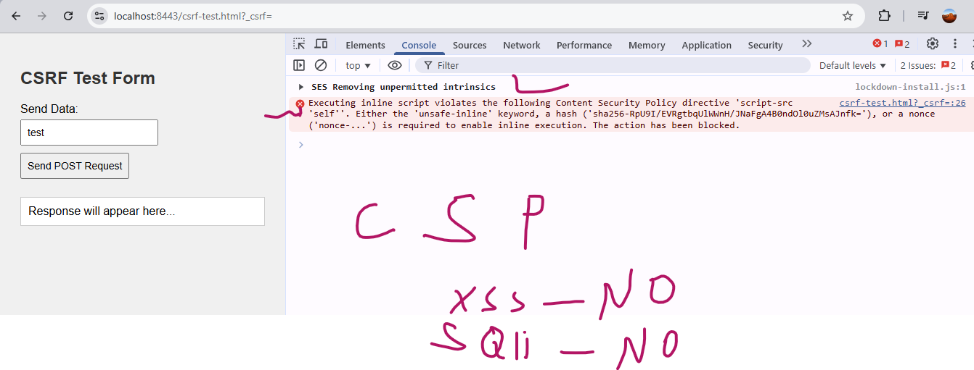

Screenshot 11: Request Blocked Without Token
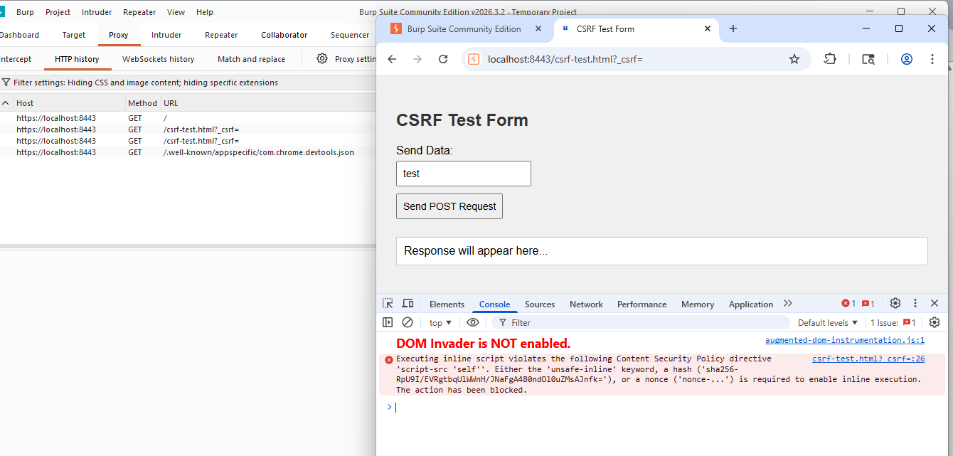

Screenshot 12: Replay with Token (Vulnerability)
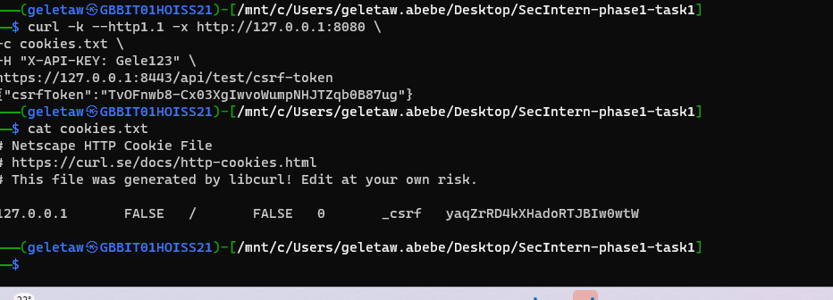

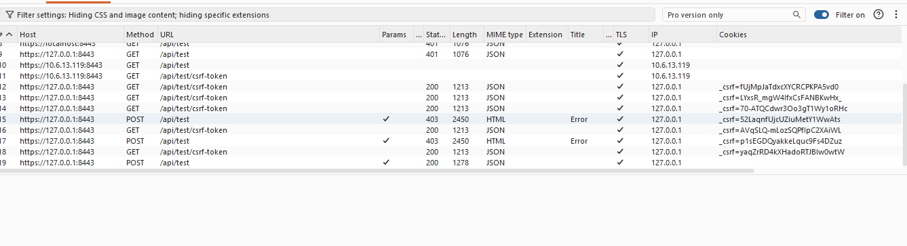

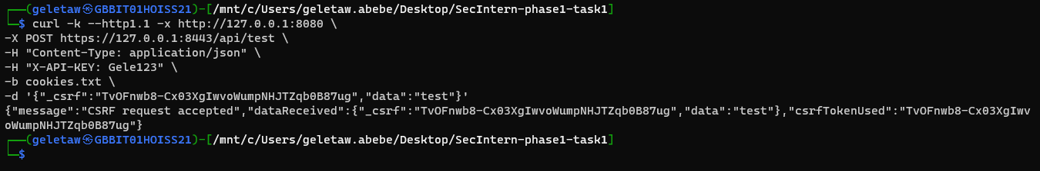

7. Additional Observation — DoS Behavior
- Excessive requests caused:
  - Application crash / slowdown
Indicates:
- Weak rate limiting handling
- Potential DoS exposure
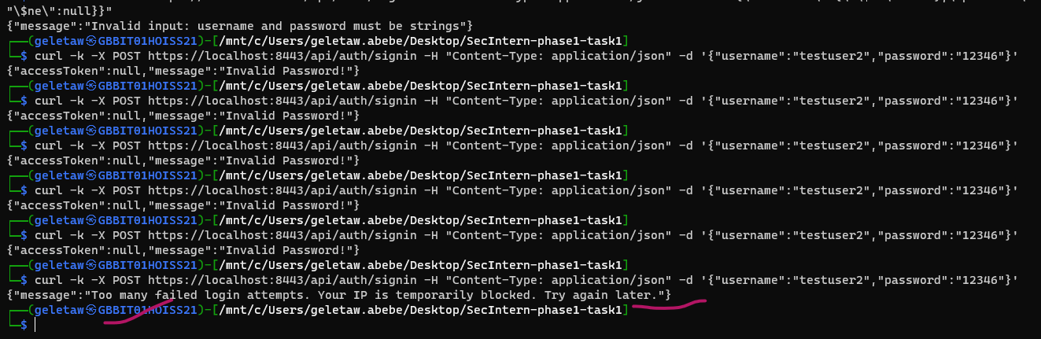

8. Security Fixes Summary
Vulnerability | Severity | Status
.git Exposure | 🚨 Critical | ✅ Fixed
Package Info Exposure | 🚨 High | ✅ Fixed
SQL Injection | ❌ Not Found | ✔ Protected
CSRF | ⚠️ Partial | ✅ Fixed
Rate Limiting | ⚠️ Weak | ✅ Fixed but Needs tuning

Recommendations
- Remove sensitive directories (.git)
- Implement strict access control
- Improve CSRF token lifecycle (one-time tokens)
- Strengthen rate limiting
- Hide package metadata
- Implement Web Application Firewall (WAF)

Conclusion
The ethical hacking exercise successfully demonstrated how security controls can prevent common attacks such as SQL Injection, while also revealing critical misconfigurations such as exposed .git directories.
Although protections like rate limiting and CSRF tokens were implemented, further improvements are required to fully secure the application against replay attacks and denial-of-service conditions.

